**Session take-home package**

Thank you for your interest and attendance at our breakout session, ***Consulting vs. Industry: Charting a Professional Career Path.***

This package contains a condensed version of the N8TRAITS self-assessment tool discussed during the session, links for some additional resources, and contact information for your presenters.

We hope you found the content presented to be informative and useful in making the best career decisions for you. Please feel free to contact us, especially if you have an interest in finding out more about opportunities at Daugherty Business Solutions.

Best wishes for your professional future,

Monika Mueller and Ron Stacey

**N8TRAITS Exercise**

The N8Traits system (now renamed as Leadership DNA), is a way to measure your particular talents and struggles based on a series of preference questions rated on a percentage scale from 0 to 100. Like MBTI and other systems, it groups respondents into ‘types’ based on their placement on these scales. Unlike MBTI, the measurement is not binary – you are never classified under one characteristic or another, but are given percentages of affinity for each. Also unlike MBTI, the findings tend to be accurate for over 90% of the population and remain stable over time.

There are two scales, one for core work-life drivers, and one for planning or behavioral attitudes. The first measures a range distribution for 10 traits paired in 5 groups, and the second measures a range distribution for 6 traits paired in 3 groups.

In the full system, a participant gets not only the scale results and the profile or type he / she fits into, but also information the percentage of all people that have similar results, the degree of difference / affinity with team members who also take the assessment, in-depth insights on the natural strengths & weaknesses indicated by the assessment, a compatibility chart with managers and team members, and a personalized profile.

In this greatly simplified version, you will be given a brief set of questions to rate, a charting tool and some guidelines to determine your likely profile type, along with some insights into what that type might mean in terms of career directions.

**Instructions for the questionnaire:**

Consider the following sets of criteria and rate how close you are to either one grouping or the other, using the scale below. A 1 indicates complete identification with the characteristics on the left side, and a 5 indicates complete identification with those at the right side. Try to quickly choose a rating based on your first impression, without overthinking it.

|  |  |  |  |  |  |  |  |
| --- | --- | --- | --- | --- | --- | --- | --- |
|  | **Work-life Drivers** |  |  |  |  |  |  |
|  |  | **Rating Scale** | | | | |  |
| **List 1** | More important to be part of the team, fit in | 1 | 2 | 3 | 4 | 5 | More important to exercise control & take charge |
| Prefer to concentrate on current, present issues | Oriented toward future, 'to-be' vision |
| Prefer to work against an established plan | Prefer to set the agenda, plan for the group |
| More important to have a flexible approach | More important to be definite and clear in approach |
| Most comfortable with cooperation & teamwork | Comfortable with confrontation and conflict |
|  |  |  |  |  |  |  |  |
| **List 2** | Reserved about new ideas, prefer to study before doing | 1 | 2 | 3 | 4 | 5 | Enthusiastic about new ideas, prefer to implement now |
| Prefer to think (internal) | Prefer to expresss (external) |
| Consider, analyze | Think out loud |
| Remain more withdrawn | Engage, network |
| Private, guarded | Public, open |
|  |  |  |  |  |  |  |  |
| **List 3** | Change, adaption | 1 | 2 | 3 | 4 | 5 | Steadiness, maintain |
| Conflict / challenging | Harmony / support |
| Rational / Objective, cool | Sensitive to emotions / sympathetic, warm |
| Results-driven | Relationship-driven |
| Questioning, impatient | Tolerant |
|  |  |  |  |  |  |  |  |
| **List 4** | Comfortable with general information | 1 | 2 | 3 | 4 | 5 | Like specifics |
| Spur-of-the-moment | Structured |
| Improvisation / Instictive approach | Organization / Analytical approach |
| Verbal communication | Written advice |
| Low-complexity | Task focus |
|  |  |  |  |  |  |  |  |
| **List 5** | Unbelieving / Guarded | 1 | 2 | 3 | 4 | 5 | Open-minded / Hopeful |
| Dissenting | Comfortable |
| Critical thinking | Accepting |
| Fearful | Easily satisfied |
| Calculating | Have faith |

|  |  |  |  |  |  |  |  |
| --- | --- | --- | --- | --- | --- | --- | --- |
|  | **Work-life Attitudes** |  | | | | |  |
|  |  | **Rating Scale** | | | | |  |
| **Scale 1** | Oriented toward content, well-established information, known process | 1 | 2 | 3 | 4 | 5 | Oriented toward pioneering, creating new content, exploring the unknown |
|
|  |  |  |  |  |  |  |  |
| **Scale 2** | Caution, need to understand issues thoroughly before proceeding, oriented toward security | 1 | 2 | 3 | 4 | 5 | Risk-taking, comfortable with leaping before looking, oriented toward potential rewards |
|
|  |  |  |  |  |  |  |  |
| **Scale 3** | Anchored, oriented toward established knowledge | 1 | 2 | 3 | 4 | 5 | Creative, oriented toward making something new |
|

**Charting Instructions**

Using the example below, chart your responses to the questions on the blank chart which follows. The resulting pattern will be similar to one of the type charts shown below, giving you an indication of where your profile fits. Characteristics associated with each of the profiles are included at the end, which should provide a guide to where your preferences may fall on the consulting vs. industry spectrum of careers.

On the Core Work-Life Drivers scale:

* List One moves from Cooperative on the left to Take Charge on the right, and measures your “Command Factor”
* List Two moves from Reserved on the left to Outgoing on the right, and measures your “People Factor”
* List Three moves from Fast-Paced on the left to Patient on the right, and measures your “Patience Factor”
* List Four moves from Spontaneous on the left to Planned on the right, and measures your “Structure Factor”
* List Five moves from Skeptical on the left to Trusting on the right, and measures your “Natural Trust Factor”

On the planning / behavioral attitudes scale:

* Scale One measures your alignment with Contentment on the left versus being a Pioneer on the right
* Scale Two measures your alignment with being Cautious on the left versus being a Risk-Taker on the right
* Scale Three measures your tendency to be Anchored on the left versus being Creative on the right

**Example Chart:**

**List 1**

**List 2**

**List 3**

**List 4**

**List 5**

**1**

**2**

**3**

**4**

**5**

**Cooperative**

**Reserved**

**Fast-Paced**

**Spontaneous**

**Skeptical**

**Take Charge**

**Outgoing**

**Patient**

**Planned**

**Trusting**

**Now, chart your results:**

**List 1**

**List 2**

**List 3**

**List 4**

**List 5**

**1**

**2**

**3**

**4**

**5**

**Cooperative**

**Reserved**

**Fast-Paced**

**Spontaneous**

**Skeptical**

**Take Charge**

**Outgoing**

**Patient**

**Planned**

**Trusting**

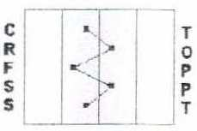 **Profile types by chart pattern:**

**Initiator**

**Adaptor**

**Stylish Thinker**

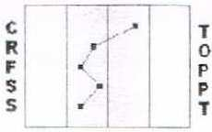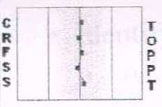

**Reflective Thinker**

**Community Builder**

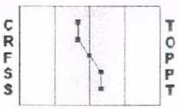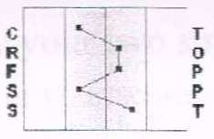

**Relationship Builder**

**Engager**

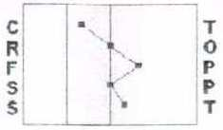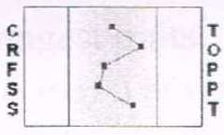

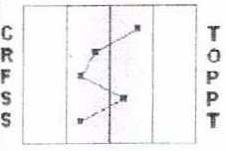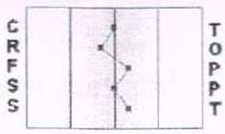

**Strategist**

**Facilitator**

**Influencer**

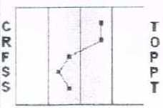

**Stylish Thinker**

**Style group characteristics:**

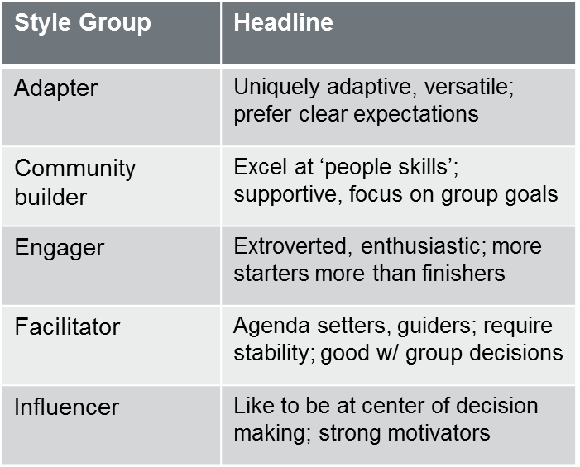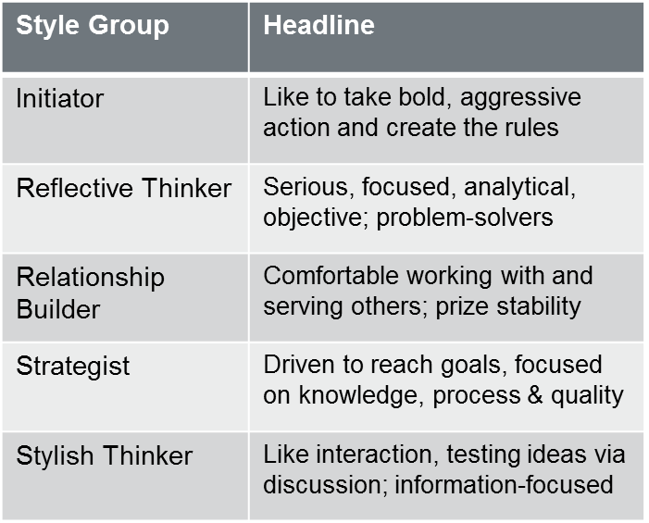

**Additional Resources**

**MBTI:** <http://www.myersbriggs.org/my-mbti-personality-type/mbti-basics/>

**SDI:** <http://www.strengthdeployment.com/sdi/about-sdi-an-overview/>

**N8Traits:** <http://www.leeellis.us/leadership-behavior-dna-assessment>

**Daugherty:** [http://www.Daugherty.com](http://www.daugherty.com/)

**Career Options:**  <http://www.forbes.com/sites/dailymuse/2012/11/02/is-consulting-right-for-you/>

<http://www.strategyexpert.com/articles/leaveconsulting>

<http://www.jeremyfilliben.com/2009/08/corporate-versus-consulting-jobs.html>

<http://cranfieldexperience.blogspot.com/2007/10/consulting-vs-industry-is-it-valid.html>

<http://www.quicksprout.com/2013/07/11/why-consulting-is-a-career-everyone-needs-to-experience/>

<http://www.careercornerstone.org/industries.htm>

**Professional & Technical** <http://www.patca.org/>

**Consultants Association:**

**Contact Information**

**Monika Mueller** [monika.mueller@daugherty.com](mailto:monika.mueller@daugherty.com)

Managing Directory, Atlanta Branch <http://www.linkedin.com/pub/monika-mueller/11/131/996/en>

**Ron Stacey** [ronald.stacey@daugherty.com](mailto:ronald.stacey@daugherty.com)

Program Manager <http://www.linkedin.com/pub/ron-stacey-mba-pmp/7/7a3/772>

**Jen Moulton** [jen.moulton@daugherty.com](mailto:jen.moulton@daugherty.com)

Recruiting Manager, Atlanta Branch <http://www.linkedin.com/in/jenmoulton/en>

**Atlanta Office**

Daugherty Business Solutions

3438 Peachtree Road, Suite 950, Atlanta GA 30324

(404)

[www.Daugherty.com](http://www.Daugherty.com)